JsonWebToken

Without Token.
This proves that the API is protected.
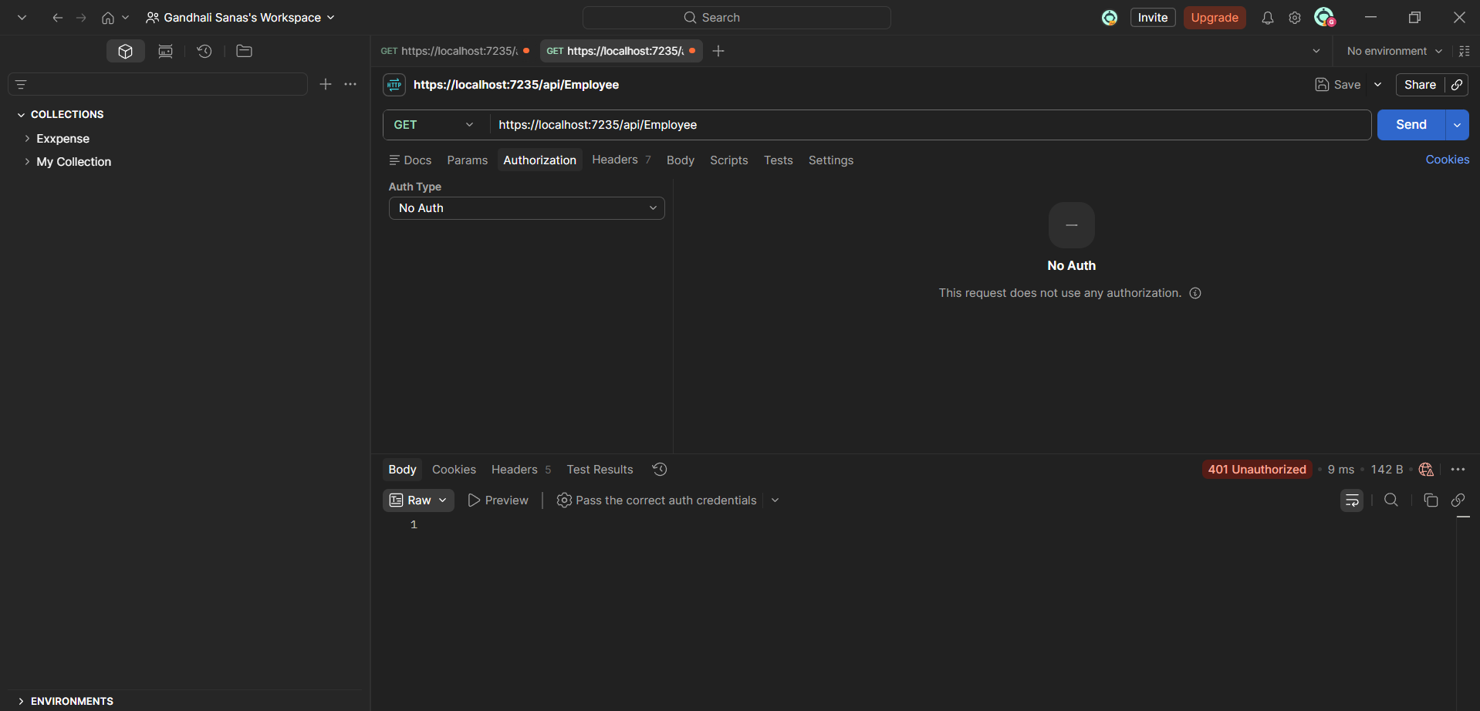

With Valid JWT Token
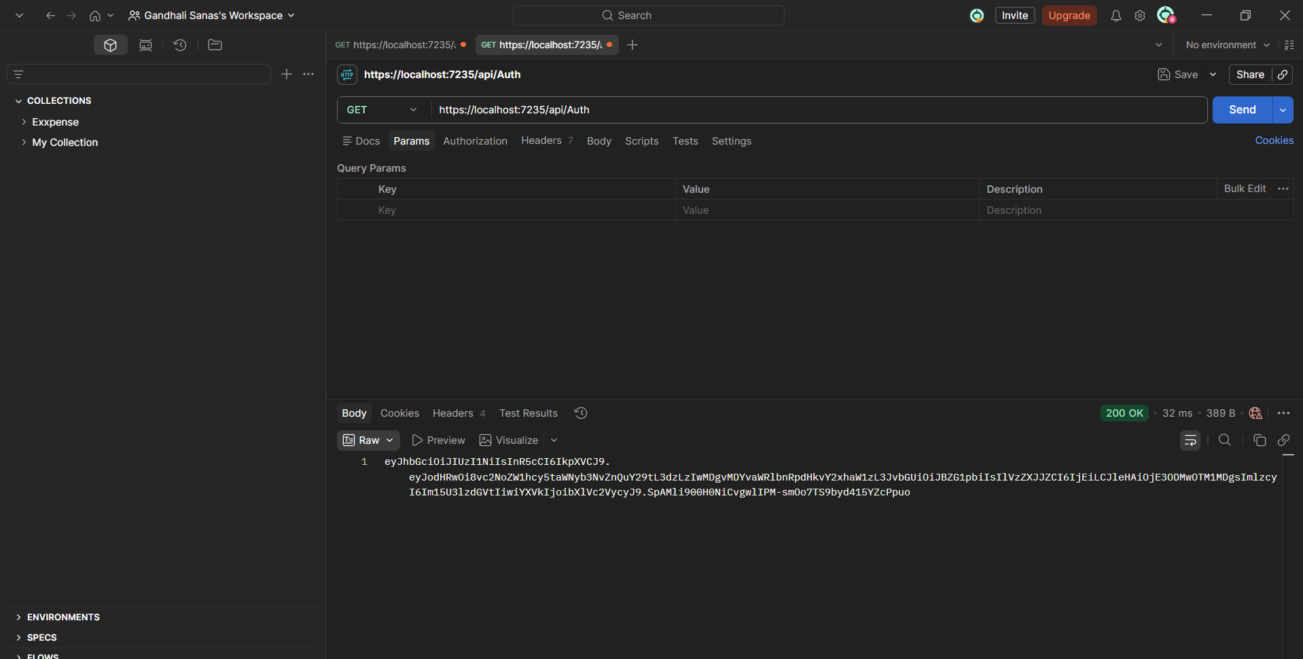

Using valid token and passing to authorization tab
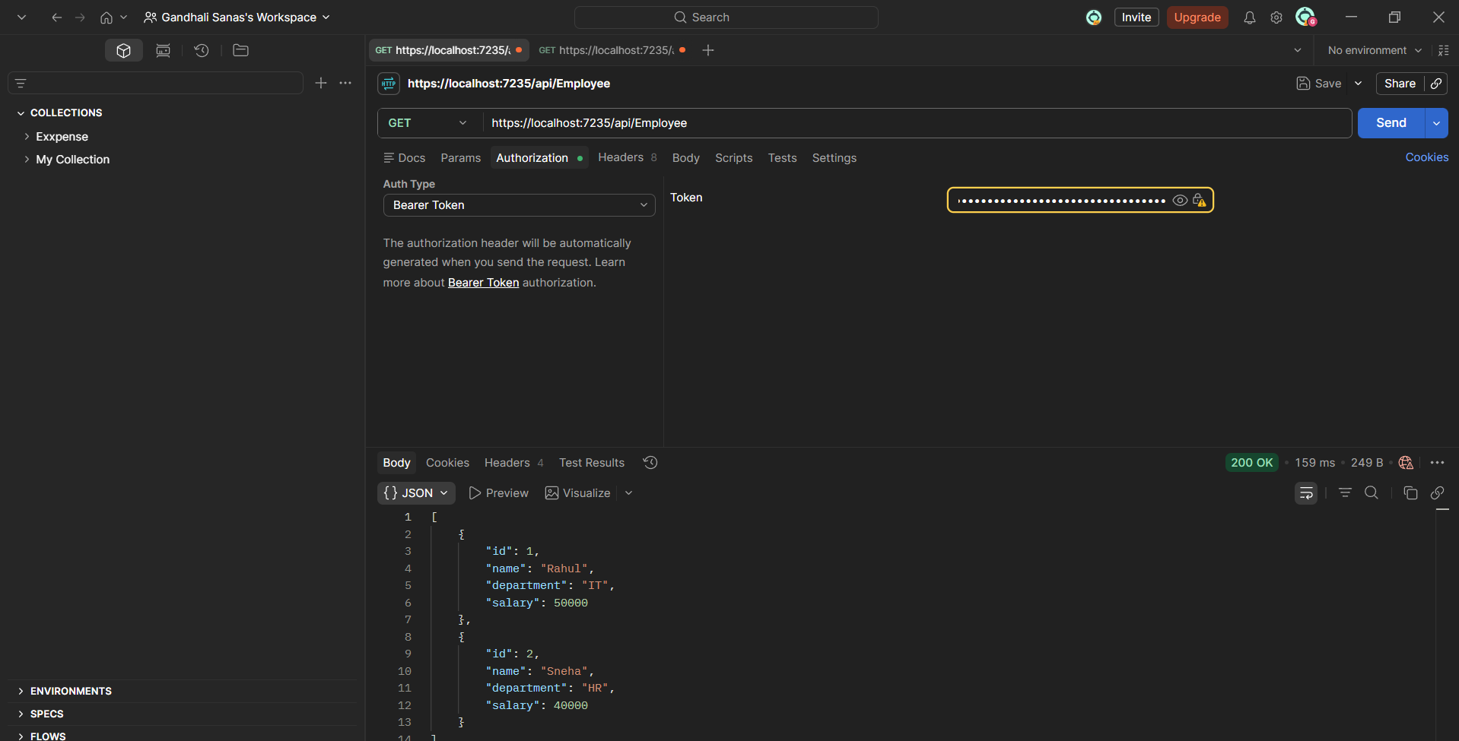

Invalid token
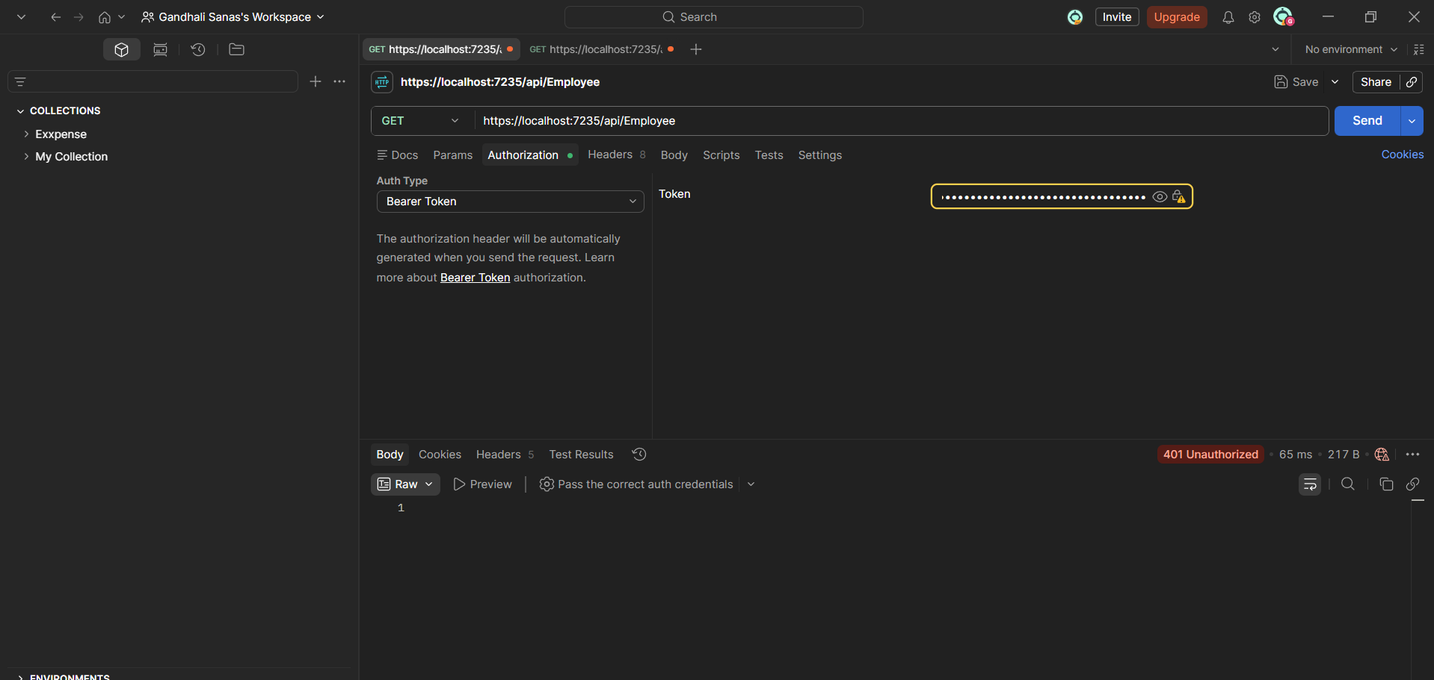

Check for JWT expiration.
Modify the duration for ‘expires’ attribute to 2 minutes.
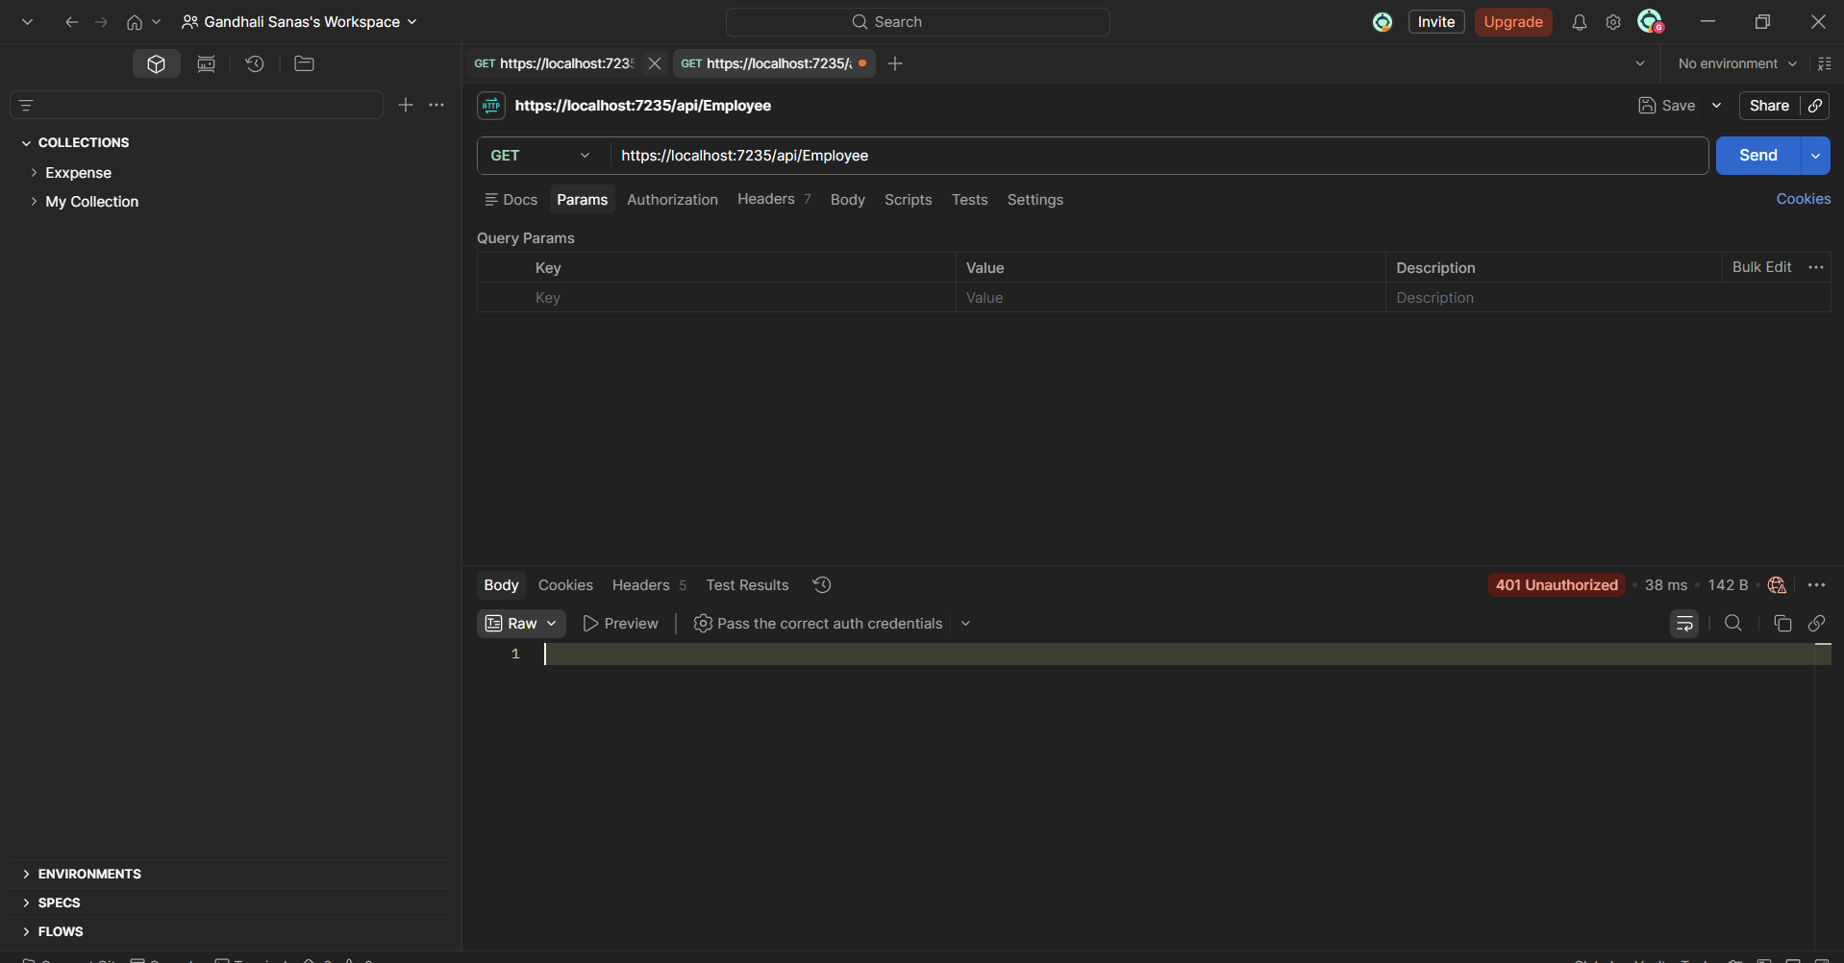

Including the role ‘POC’ in the Authorize attribute in the Employee controller.
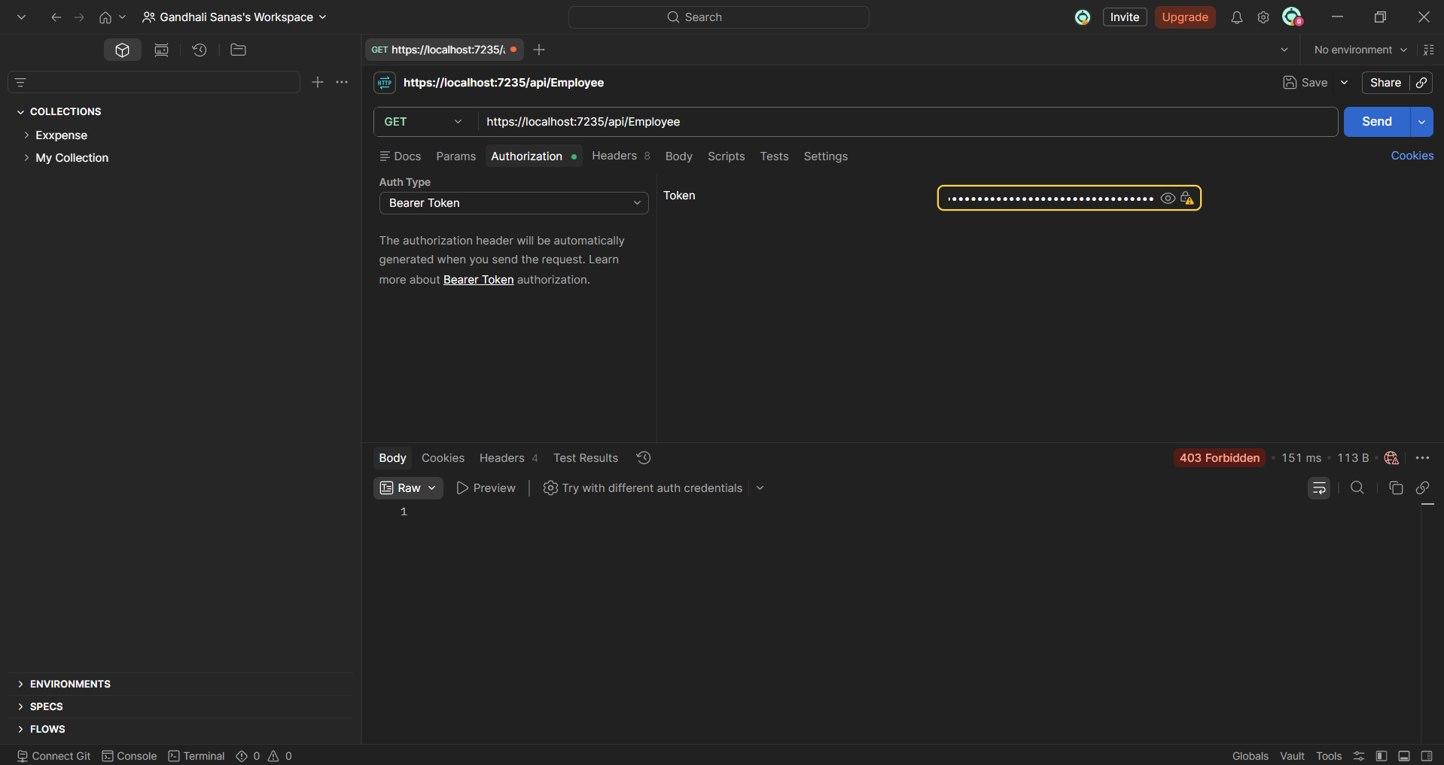

Include the role ‘Admin’ along with ‘POC’ in the Authorize attribute in the Employee controller.
